# Assignment-5

Submitted by Weerdhawal Chowgule

**Objective :**

* In this project we implement the regression to infer the rotation of a ring image to by inferring the rotation on the basis of the training image.
* Secondly as the input images are of the size 100*100 the total feature length would be (D=10000) which is too long(as MATLAB crashes) so as per the assignment question feature selection has been implemented.
* Next using Linear regression and selected feature Bayesian Solution is found by adding the regularization term
* Next Non-Linear(polynomial Regression) has been implemented using regularization.
* Lastly Dual Non-Linear regression has been implemented without using feature selection.
* Finally the inferred angle θ’ and ground truth of each is calculated for all the given images I

ALGORITHM :

1. Linear Regression:

* In Linear Regression use the following equations to get the results:







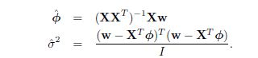

* From the first equation we get the y-intercept and then calculate the gradiant vector in the second equation. Next that vector is made into and diagonal co-variance matrix.Atlast learning is done by the final equation

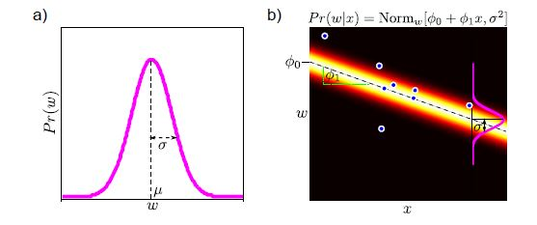

* The above two graphs show the final model graphs which are obtained.

1. Bayesian Linear Regression:

* The Bayesian Regression is applied using the following formulas:



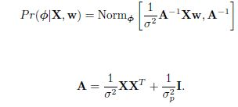



* Using the first equation the prior is calculated then using the next equation posterior distribution is calculated.Posterior distribution is calculated using Bayes rule. Finally the representation is as

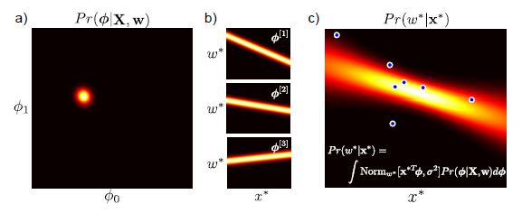

1. Non-Linear Regression:

The relationship between the data x and the world w is not linear one. Evaluation of Z is done by observing the original x against each of the radial basis functions (Gaussians) and a constant function.Mean of the predictive distribution can be formed by taking a linear sum functions, the weights are estimated by maximum likelihood estimation of the linear regression model using the nonlinearly transformed data z instead of the original data x.Finally the mean is calculated which is the sum of these functions and the variance to is calculated.

C:\Users\weerd\AppData\Local\Microsoft\Windows\INetCache\Content.Word\crop a1.jpg

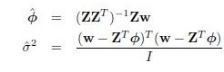

* The final representation of Non Linear Regression is as follows:

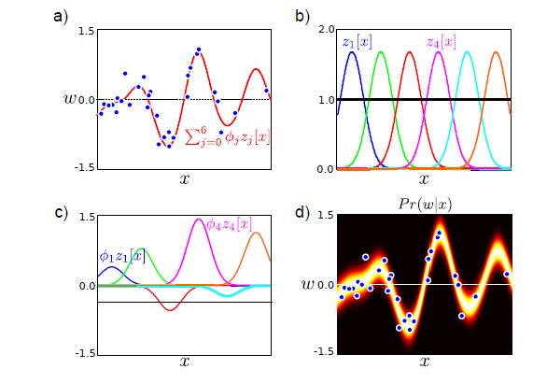

1. Dual Non Linear

* In dual Non linear here we do not use feature selection and also in training we do not use the whole data set we sparsely select few images for training and then run the algorithm and then the testing.

**RESULTS:**

|  |  |  |  |
| --- | --- | --- | --- |
|  | train errors | test error | deviation |
| Original | 1.11E-08 | 0.6803 | 0.0075 |
| Regularized | 0.272 | 0.5948 | 0.0035 |
| Polynomial | 1.7568 | 3.2363 | 0.0163 |
| Duel Linear | 0.2089 | 0.7267 | 0.0057 |

**Result Images:**

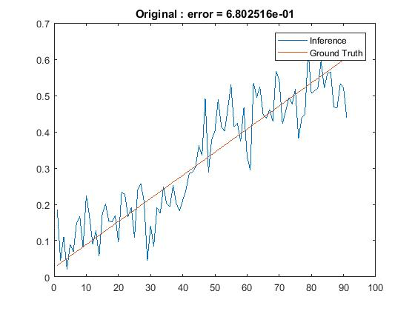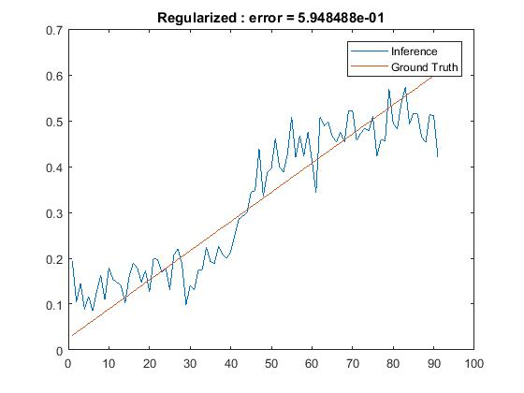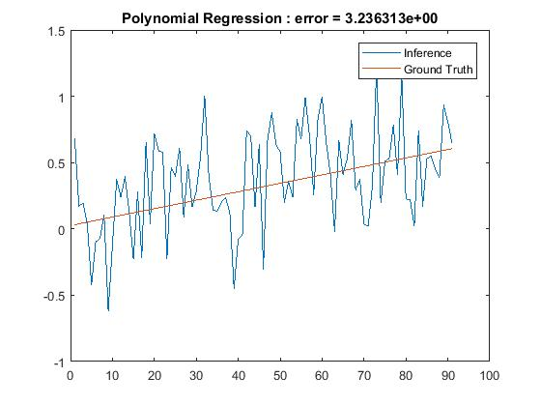

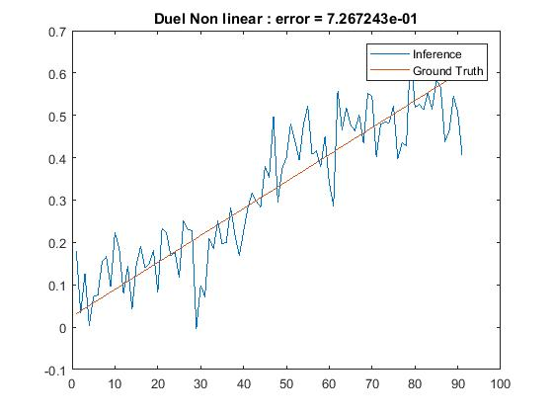

Obesrvation:

1. Change in the lambda values give slight variation in the solution it is observed.
2. Also we can see that Polynomial Regression gives the least error so it satisfies that it is the best as we have studied.But, I am getting a slight higher value of the Dual Non-Linear which is not what I actually expected.

NOTE:

1. I have used a tool to save the covariance matrix as ‘mvnrnd’ fails if the matrix is not a positive definite.
2. ‘PD_mat.m’ is the file in the folder which is the tool.
3. <https://www.mathworks.com/matlabcentral/fileexchange/42885-nearestspd?requestedDomain=www.mathworks.com> is the link to the tool.